*191071902*

*Srushti Shah*

*T. Y. B. Tech. C. S.*

***Experiment No. 3***

***AIM*:** OOAD USING UML

***THEORY:***

**Experiment No 3: Implementation and Reengineering**

1. Illustrate the software project with respect to UP PROCESS given below and implement it using object-oriented programming language - C++

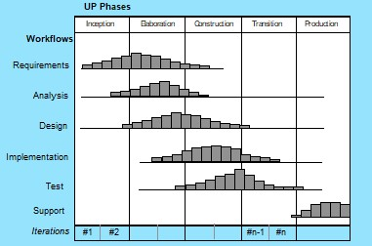

2 Apply following dimensions for Reengineering – (reverse engineering and forward engineering) of object-oriented systems. and use the UP Process for iterations or following OO PROCESS MODEL

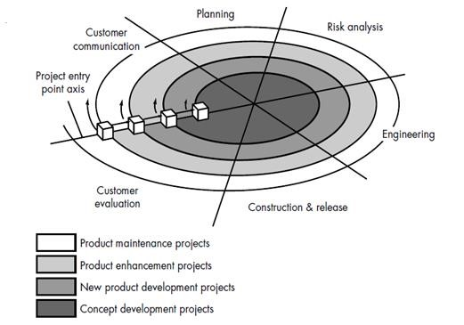

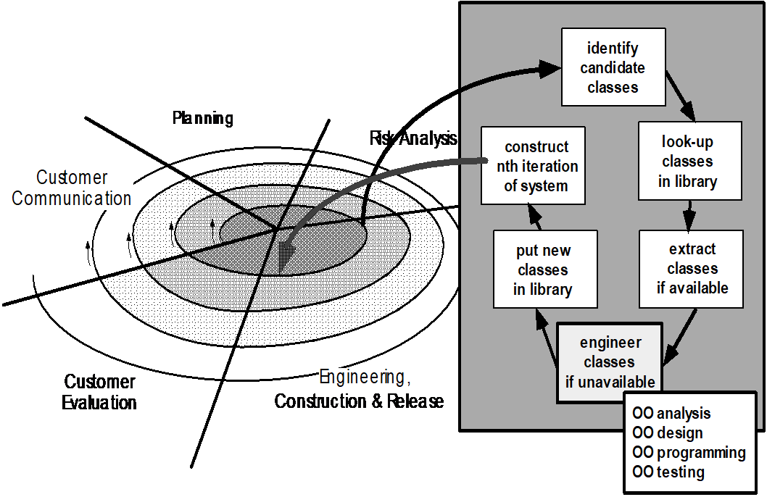

================================================================

**Experiment 3 OO System Testing**

Apply object-oriented software testing to test your software. Use the following dimensions for testing

1. Unit Testing 2. Method Testing 3. Class Testing 4. Integration Testing

5. System Testing

You can also use the open source software testing tools, open source functional testing tools, open source web application testing tools, open source performance testing tools, , open source load testing tools, and any other open source testing tools of your choice.

Given below is the list of most popular open-source testing tools

Katalon Studio , Selenium , Appium , Robotium ,Cucumber ,Watir , Sikuli

,JMeter ,WatiN ,SoapUI , Capybara ,Tarantula ,Testlink ,Windmill ,TestNG ,

Marathon ,httest , Xmind ,Wiremock ,Maven ,Espresso , FitNesse ,JUnit , Grinder ,Tsung ,Gatling ,Multi-mechanize , Selendroid ,KIF ,iMacros ,Linux Desktop Testing Tool , k6

**Unit Testing**

**Test Module: Login Page**

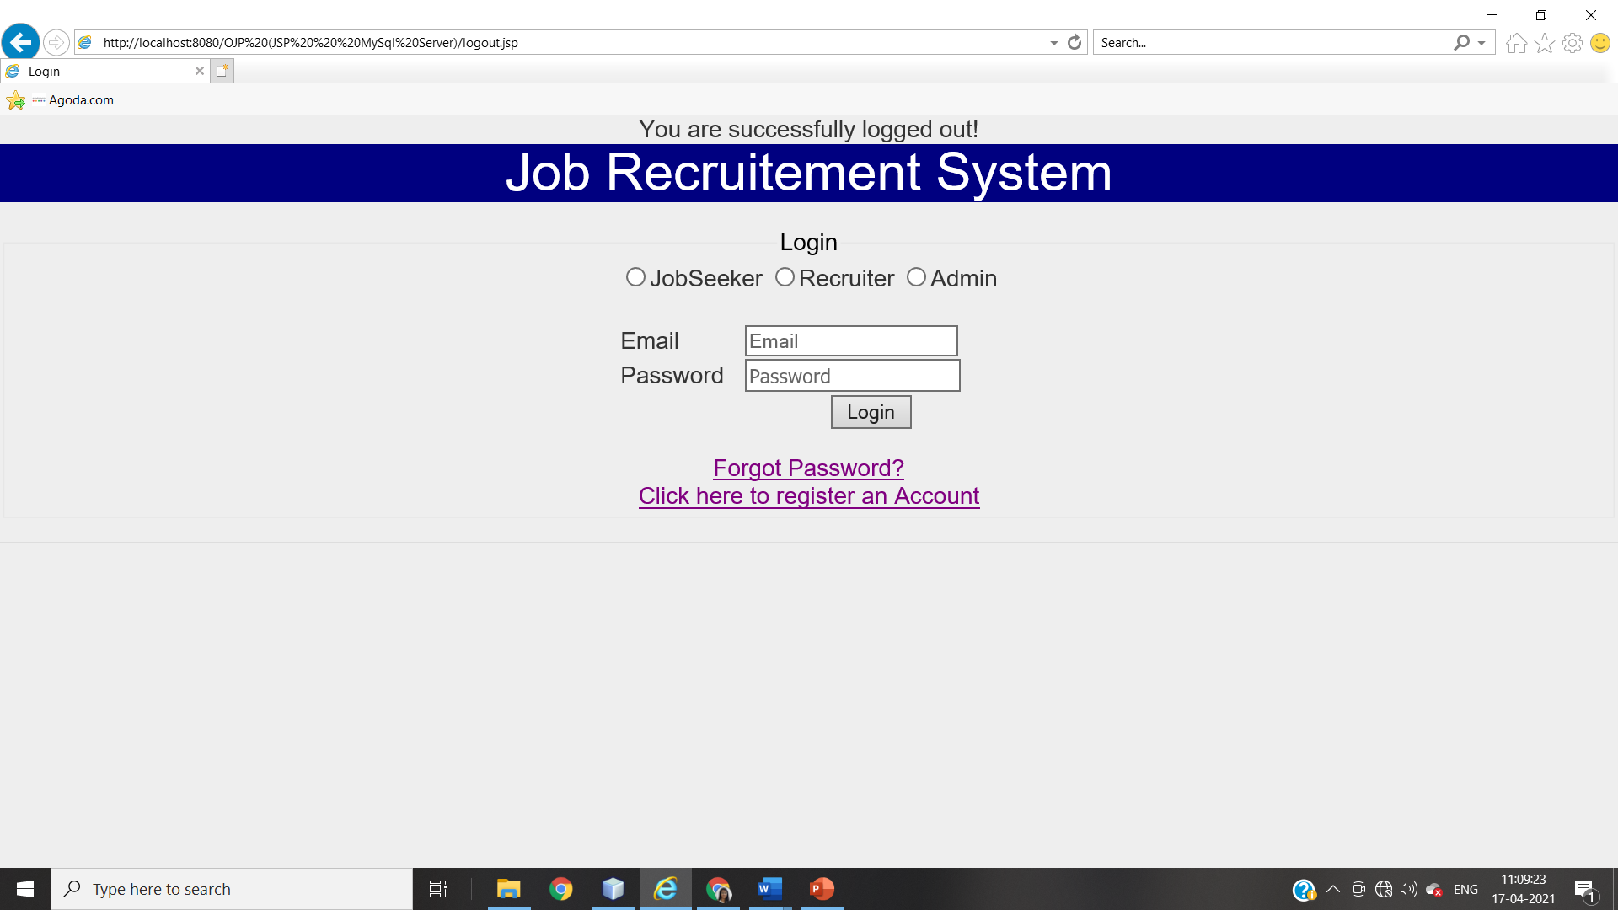

**Validation testing**

|  |  |  |  |  |  |
| --- | --- | --- | --- | --- | --- |
| **Field** | **Datatype** | **Format** | **Length** | **Character**  **Set** | **Pattern** |
| Email | String | It should contain ‘@’ | Length should be >6 | ASCII Character Set | Pattern should  _ _ @ _ _ . _ _ |
| It should contain ‘.’ |
| ‘@’ should be preceded and followed by a string |
| ‘.’ should preceded and followed by at least two letters |
| Before @ there should be at least one letter |
|  |  | | | | |
| Password | String | It should contain lower case letter a-z | The length should be >=8 | ASCII Character Set | At least one upper case, one lower case, one number and a special symbol |
| It should contain lower case letter A-Z |
| It should contain numeric letter |
| It should contain special symbol |
|  |  | | | | |
| User-type | String | Radio Button | - | - | Admin, Jobseeker or Recruiter |
|  |  | | | | |

**Verification Testing**

|  |  |  |  |
| --- | --- | --- | --- |
| **No.** | **Test Case** | **Steps** | **Result** |
| 1 | Verify if the user will be able to login with a valid email and valid password | 1. Open the browser 2. Fill the form   Valid: email: [srushti@gmail.com](mailto:srushti@gmail.com)  Password: 445$surE   1. Click Submit | Positive  Message: ‘logged in successfully’ |
|  | | | |
| 2 | Verify if a user cannot login with a valid email and invalid password | 1. Open the browser 2. Fill the form   Valid: email: [srushti@gmail.com](mailto:srushti@gmail.com)  Invalid: Password: 445$surr   1. Click Submit | Positive  Message: ‘cannot login, invalid password’ |
|  | | | |
| 3 | Verify if the form can be submitted when blank | 1. Open the browser 2. Click Submit | Positive  Message: ‘cannot submit’ |
|  | | | |
| 4 | Verify if the user type if chosen | 1. Open the browser press submit | Positive  Message: ‘choose a user type’ |
|  | | | |
| 5 | Verify if the email, password and user type match | 1. Open the browser 2. Choose a user type (Job Seeker) 3. Enter email and password   Email: [srushti@gmail.com](mailto:srushti@gmail.com)  Password: 445$surE   1. Click Submit | Positive  Message: ‘logged in successfully’ |
|  | | | |
| 6 | Verify the forgot password functionality | 1. Open the browser 2. Click on forget password | Positive:  ‘Forgot Password Page’ |
| 7 | Verify the message for invalid login | 1. Open the browser 2. Fill the form   Valid: email: [srushtigmail.com](mailto:srushti@gmail.com)  Invalid: Password: 445$surr   1. Click Submit | Positive:  Message: ‘Enter valid email and password’ |
|  | | | |
| 8 | Verify if the data in password field is visible | 1. Open Browser 2. Enter password | Positive:  ‘bullet points seen’ |
|  | | | |
| 9 | Verify if the user cannot login in the length doesn’t match |  |  |
|  | | | |

**Integration Testing**

Integration testing is performed after unit testing. Integration testing is a systematic technique for constructing the program structure while conducting tests to uncover errors associated with interfacing. All the modules of the proposed system are tested through top-down Integration testing technique.

1. **LOGIN PAGE**

The login page must route to the Home Page of respective user, provided the details are correct

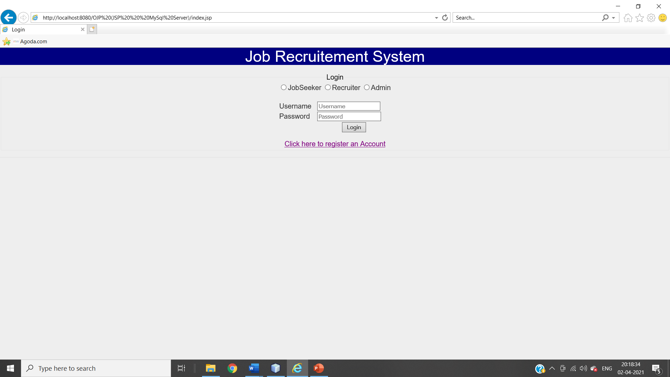

This page is for user verification purpose. Only registered users can access website.

Default username and password for admin login are

Username : admin

Password : admin

Recruiter and JobSeekers have to register before trying to access website contents.

**When Trying to Login with Wrong Details**

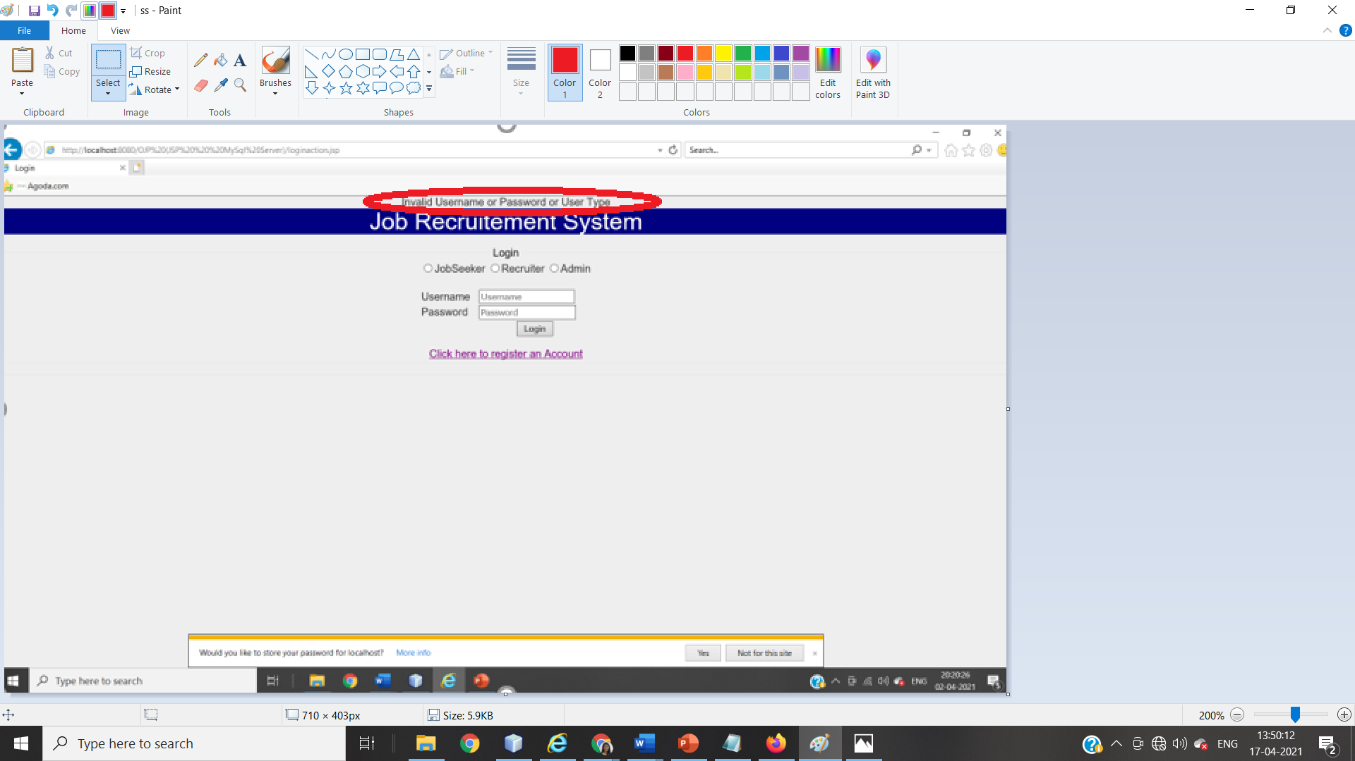

1. **NEW USER REGISTRATION PAGE**

On click on ‘click here to login’, the page must be routed to Login page

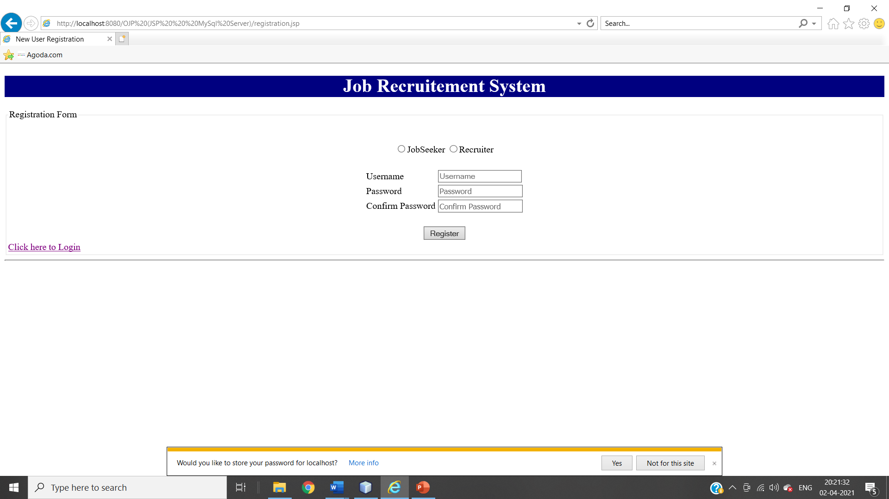

**When Passwords Don’t Match While Registration Process** 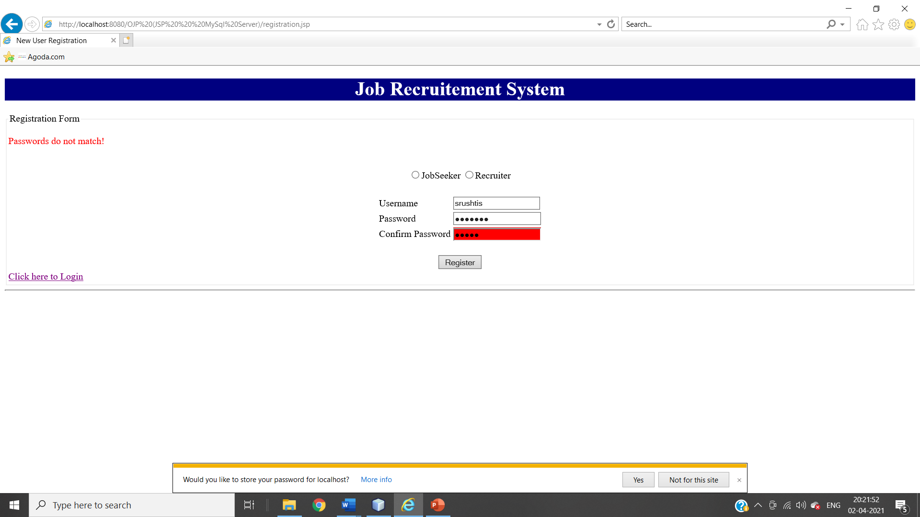

**When Registering Without Selecting Usertype** 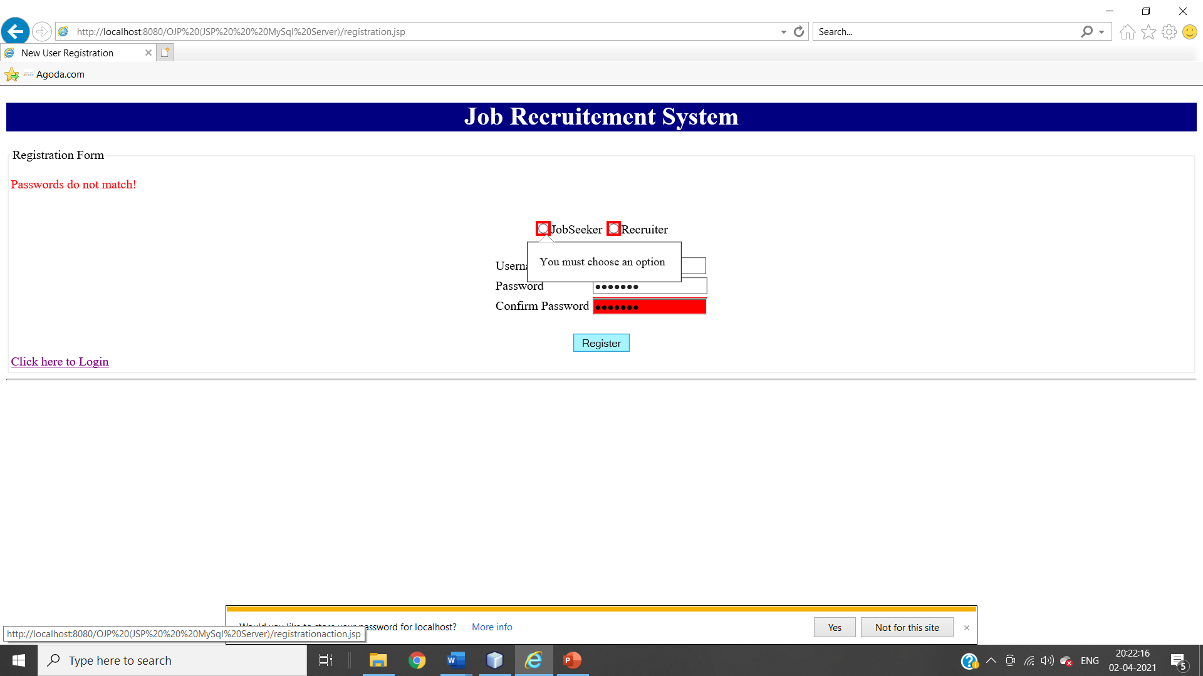

1. **LOGOUT PAGE**

When User Do Logout From Session, he should be directed to the login page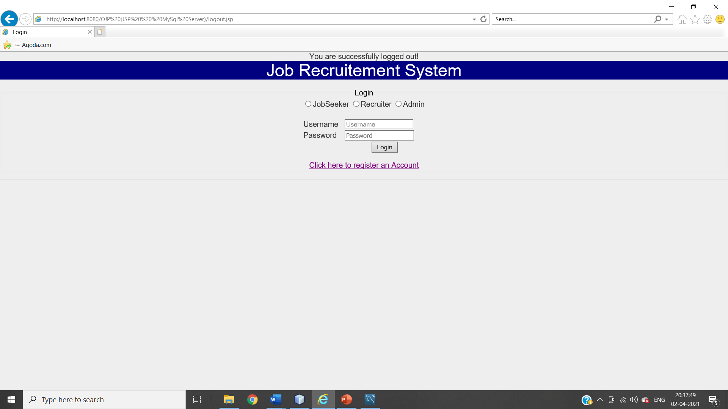

1. **JOBSEEKER HOME PAGE**

JOBSEEKER HOME PAGE

JOB STATUS CHECK

JOB SEARCH

PROFILE DETAILS

JOB ID GENERATION

APPLYING FOR JOB

**JOBSEEKER HOME PAGE**

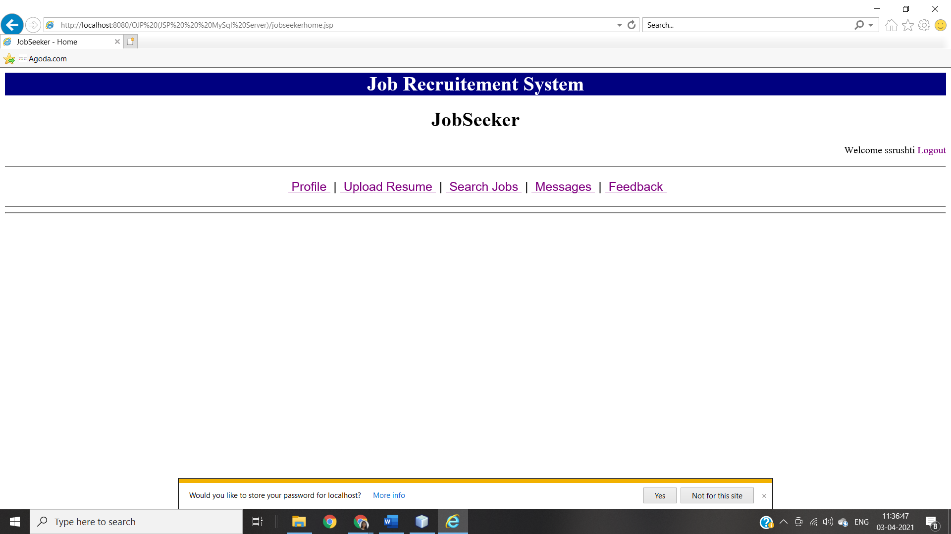

1. Profile: -

This page will open profile page of current logged in user.

1. Upload Resume:-

This link is used to upload resume.

1. Search Jobs:-

This link is used to search jobs posted by recruiters.

1. Messages:-

This link is used to view received messages about job selection.

1. Feedback:-

This link is used for feedback page to submit a feedback about website.

**‘PROFILE’ PAGE ON JOBSEEKER**

**When JobSeeker Updated There Details**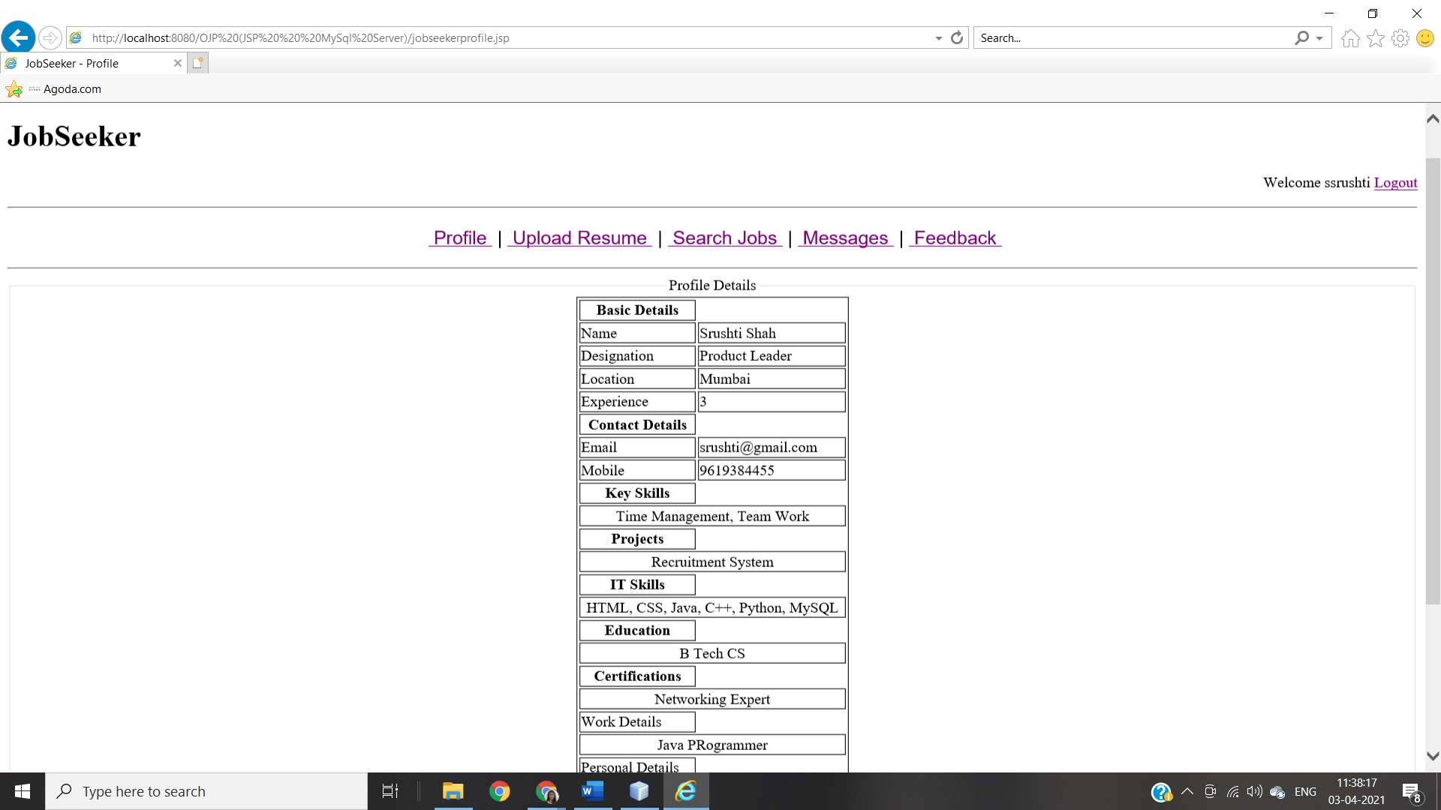 This page is for jobseeker. All possible activities for the jobseeker are listed here.

1. Edit: -

This link is used to edit/update logged jobseeker’s profile details.

**When JobSeeker Clicks On ‘Edit’**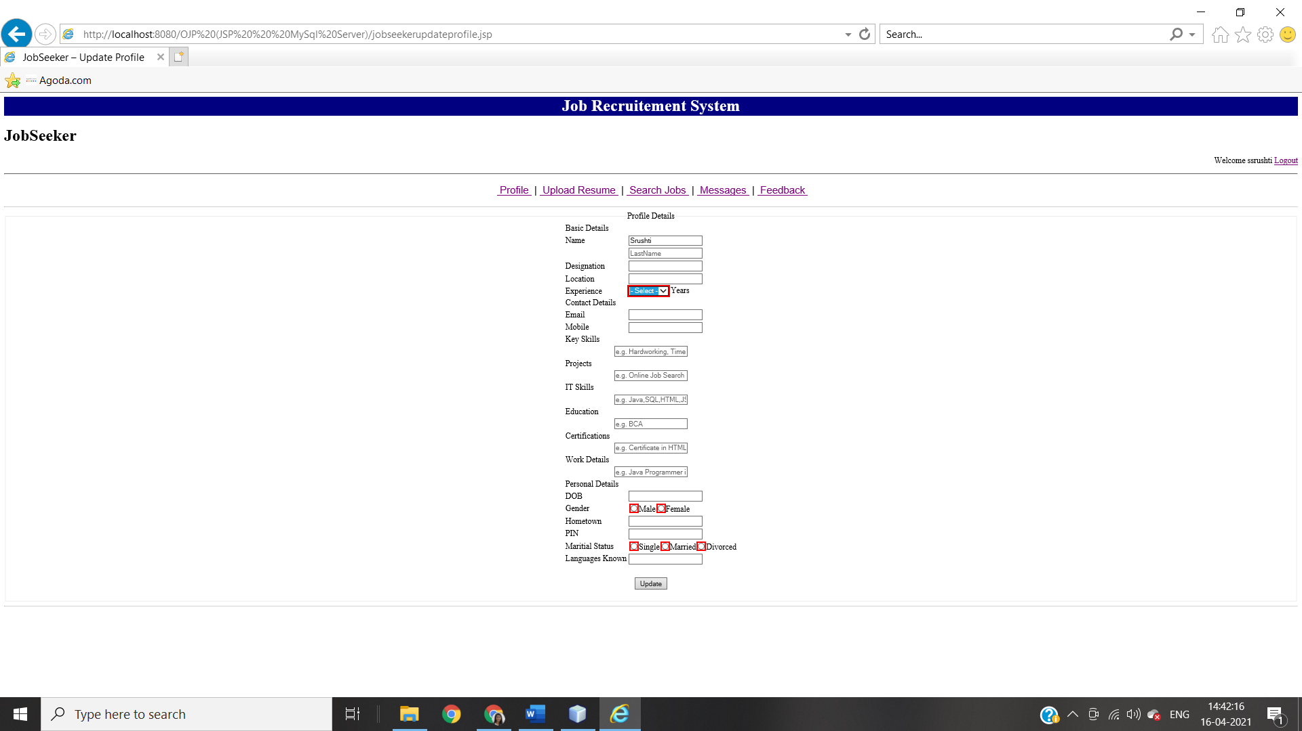

By clicking on ‘**Update**’ Button JobSeeker can update there profile details.

**When JobSeeker Is New**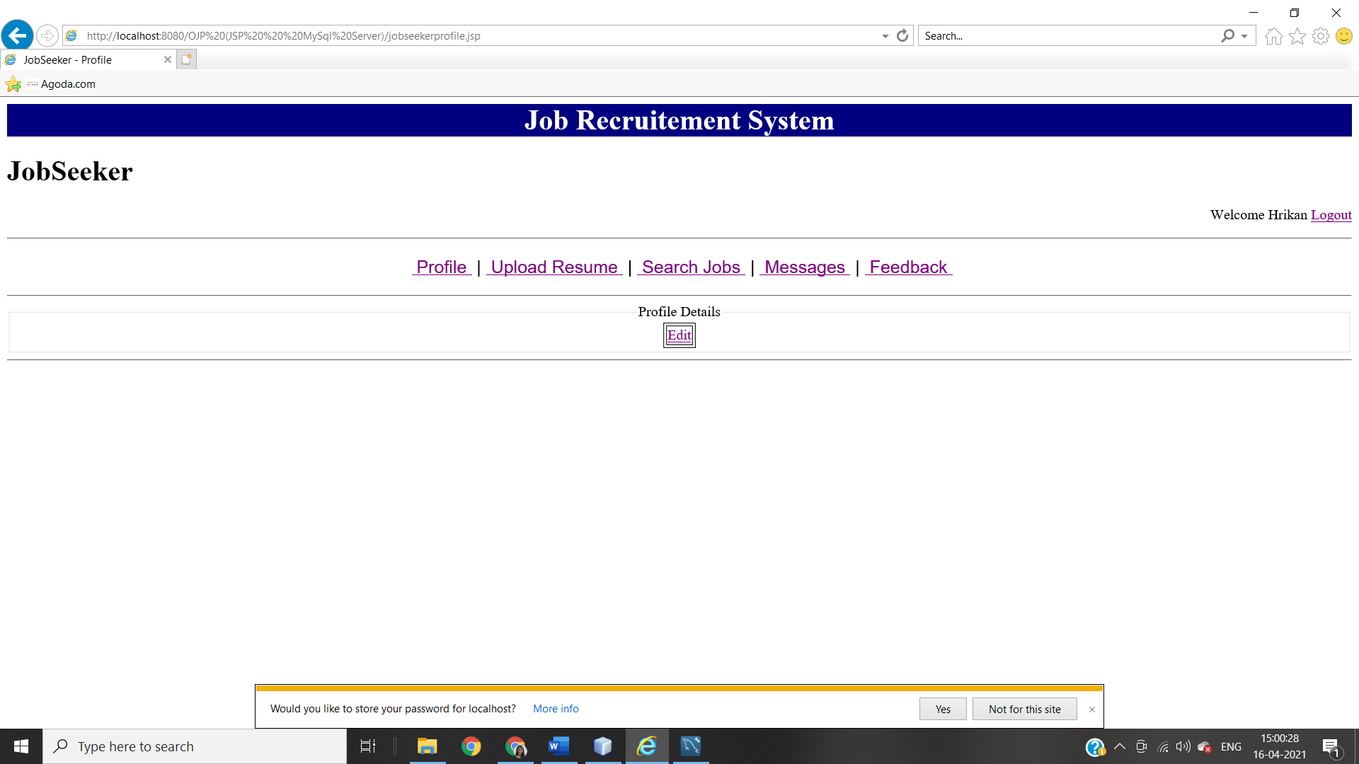By clicking on **‘Edit’** JobSeeker can edit profile details.

**‘UPLOAD RESUME’ PAGE ON JOBSEEKER**

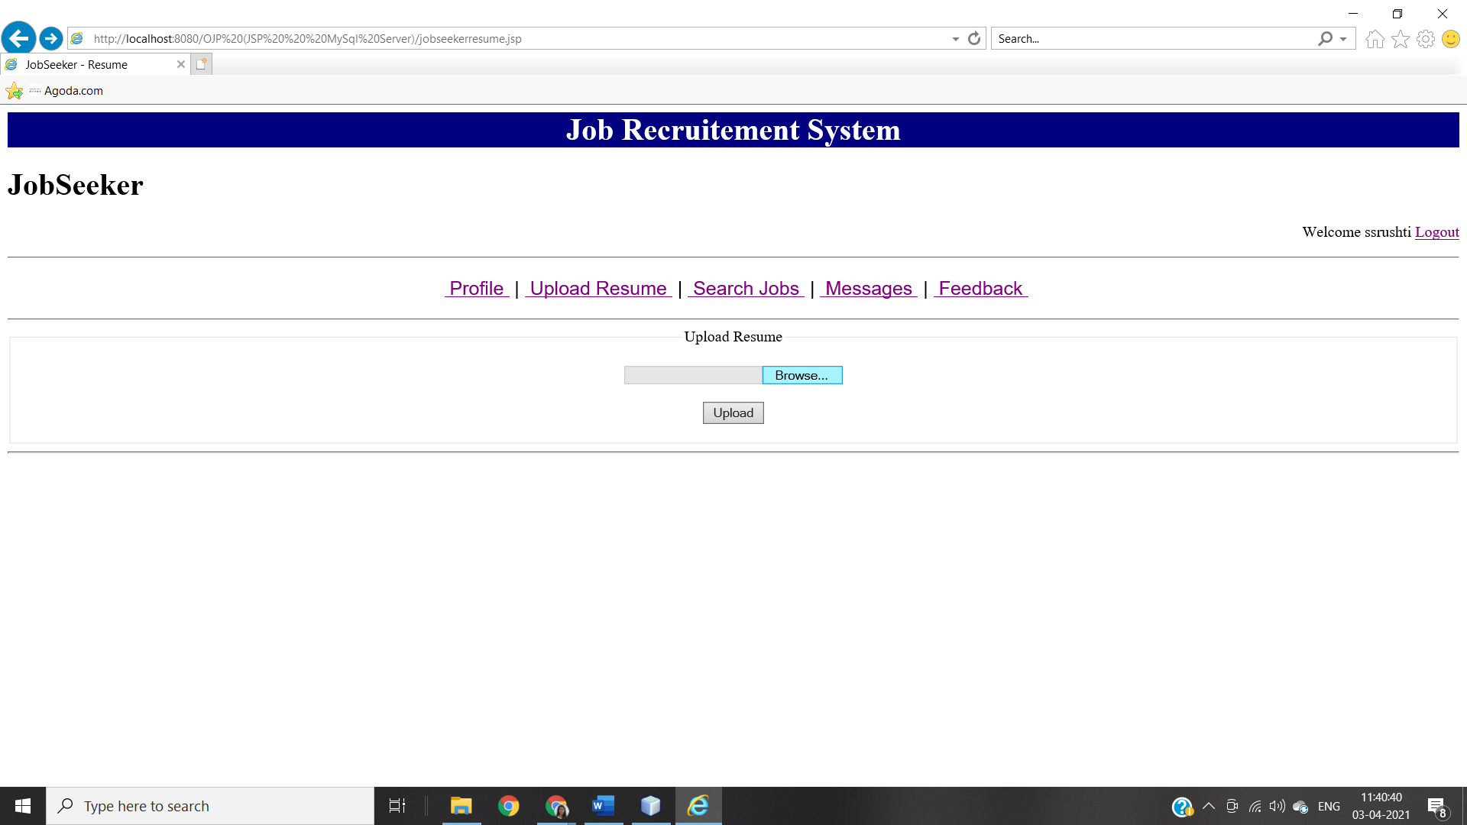By Clicking on **“Upload”** JobSeeker can upload there resume on website.

**‘SEARCH JOBS’ PAGE ON JOBSEEKER**

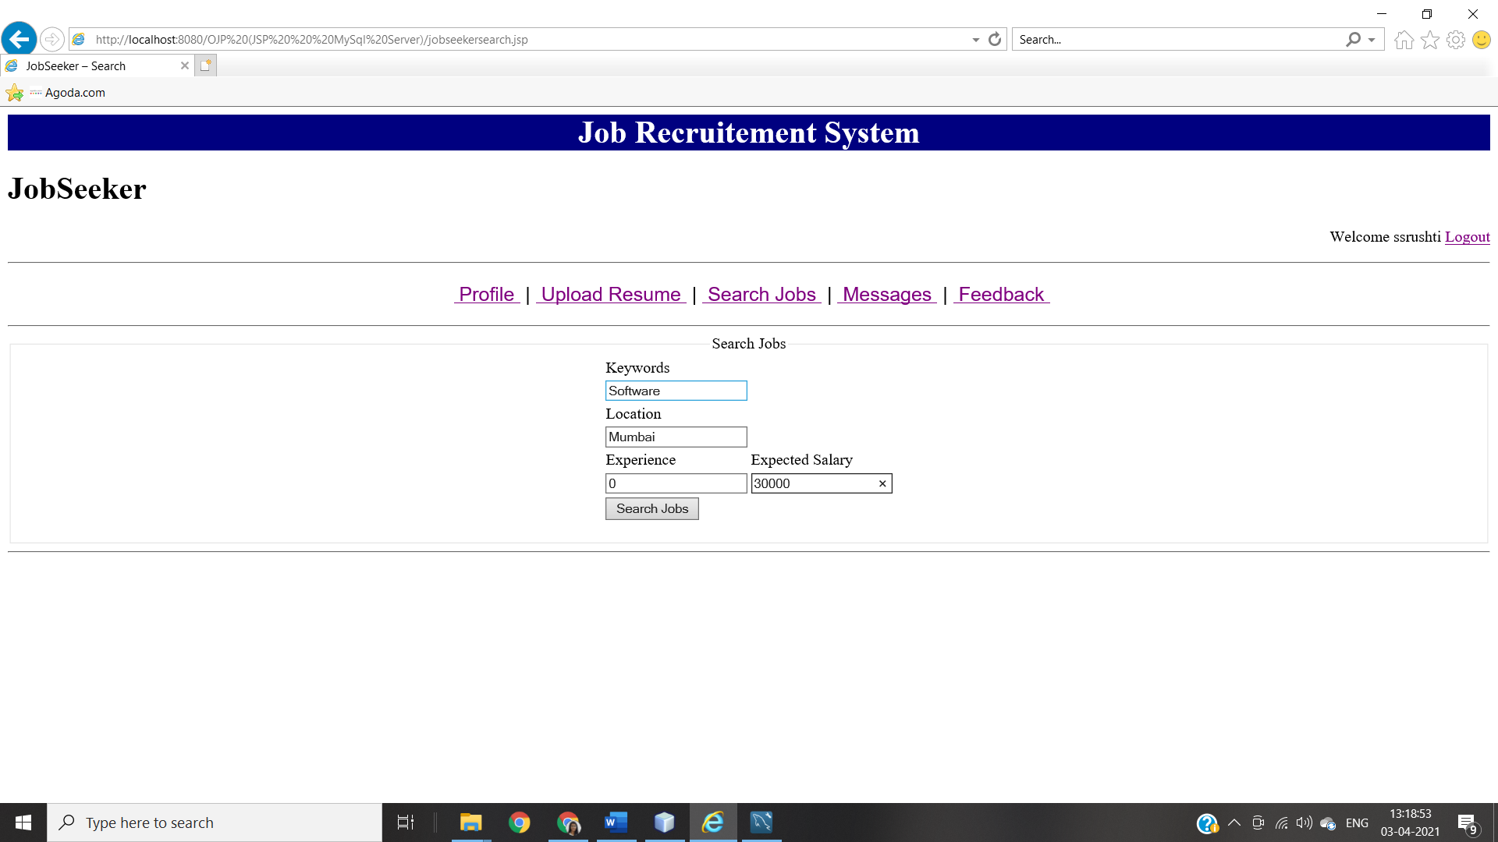

**Search Result Page When Searched For “Keywords:Software, Location:Mumbai, Experience:0, Expected Salary:30000”**

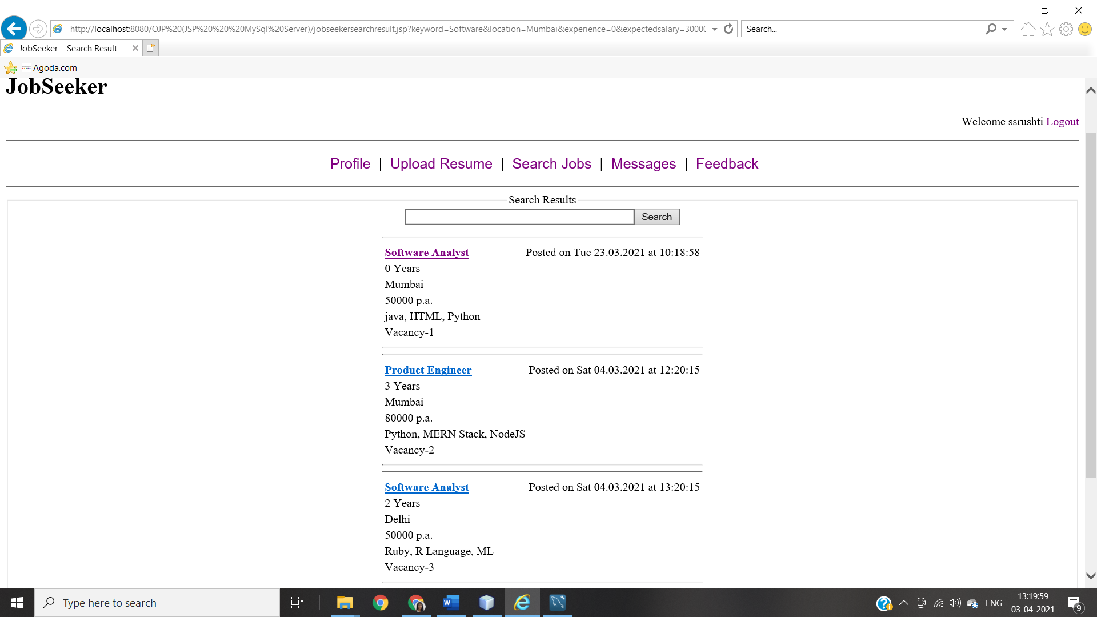

**JOB DETAILS PAGE ON JOBSEEKER**

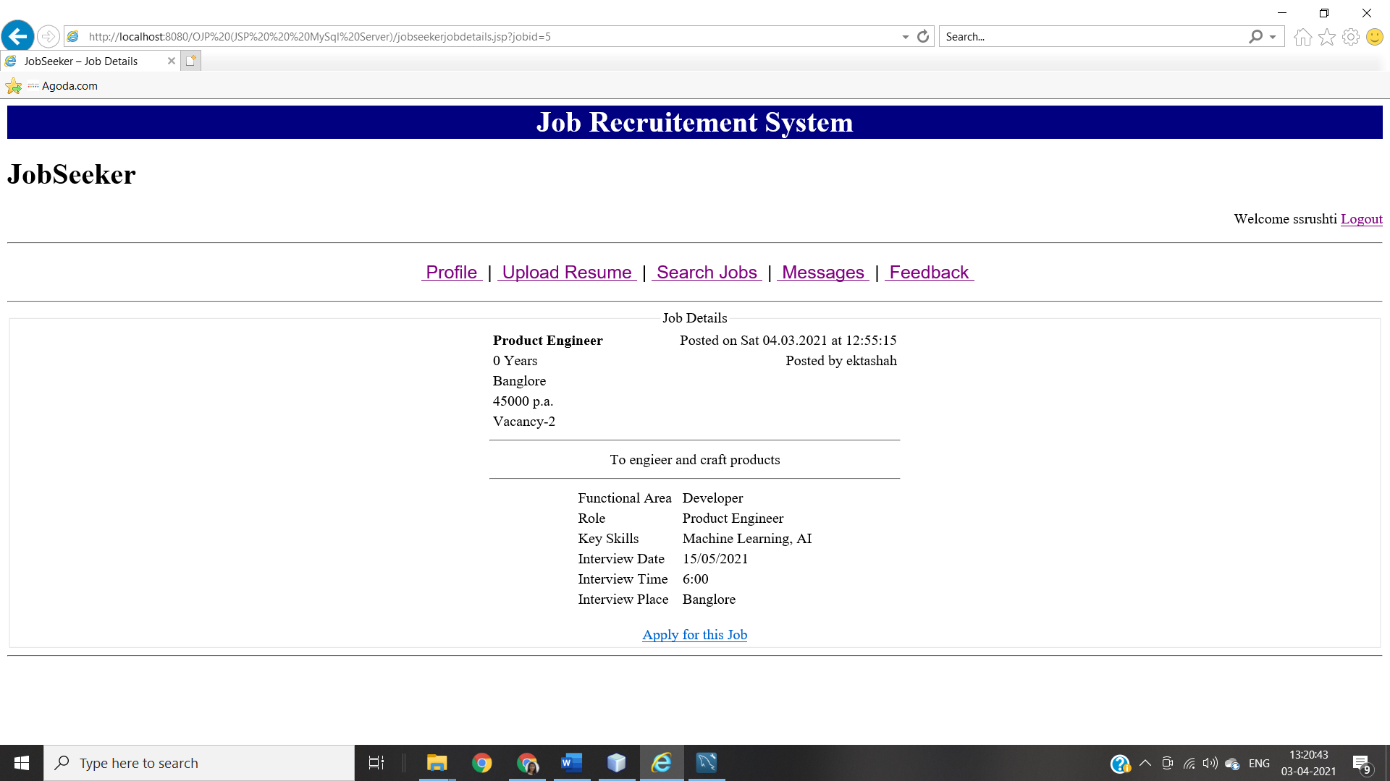By clicking on “**Apply for this Job**” JobSeeker can apply for selected job.

**‘MESSAGES’ PAGE ON JOBSEEKER**

**When There Is No Message**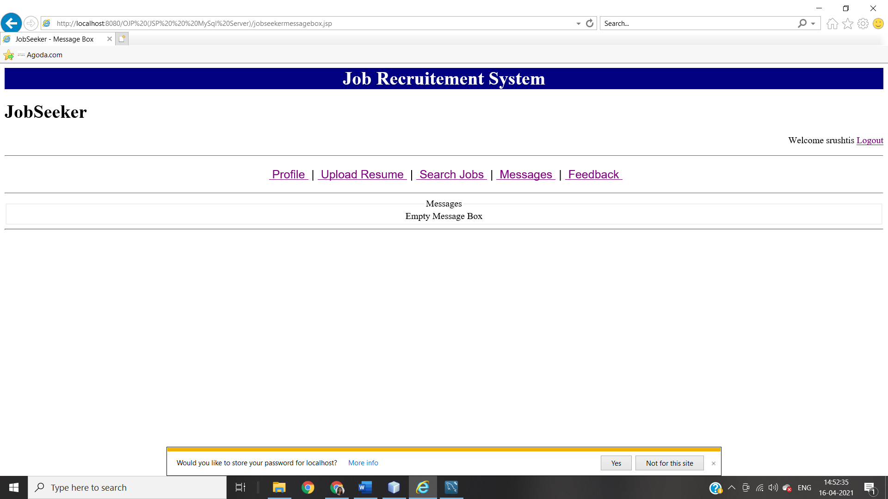

**When there are messages**

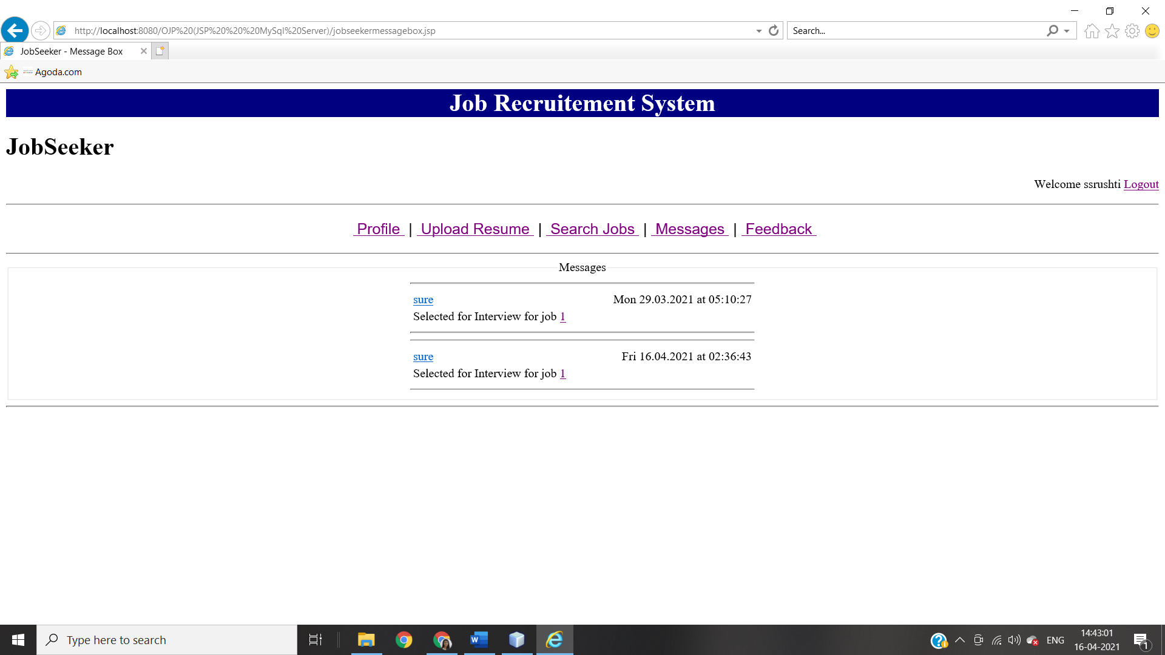

**‘FEEDBACK’ PAGE ON JOBSEEKER**

**JobSeeker’s Feedback Page**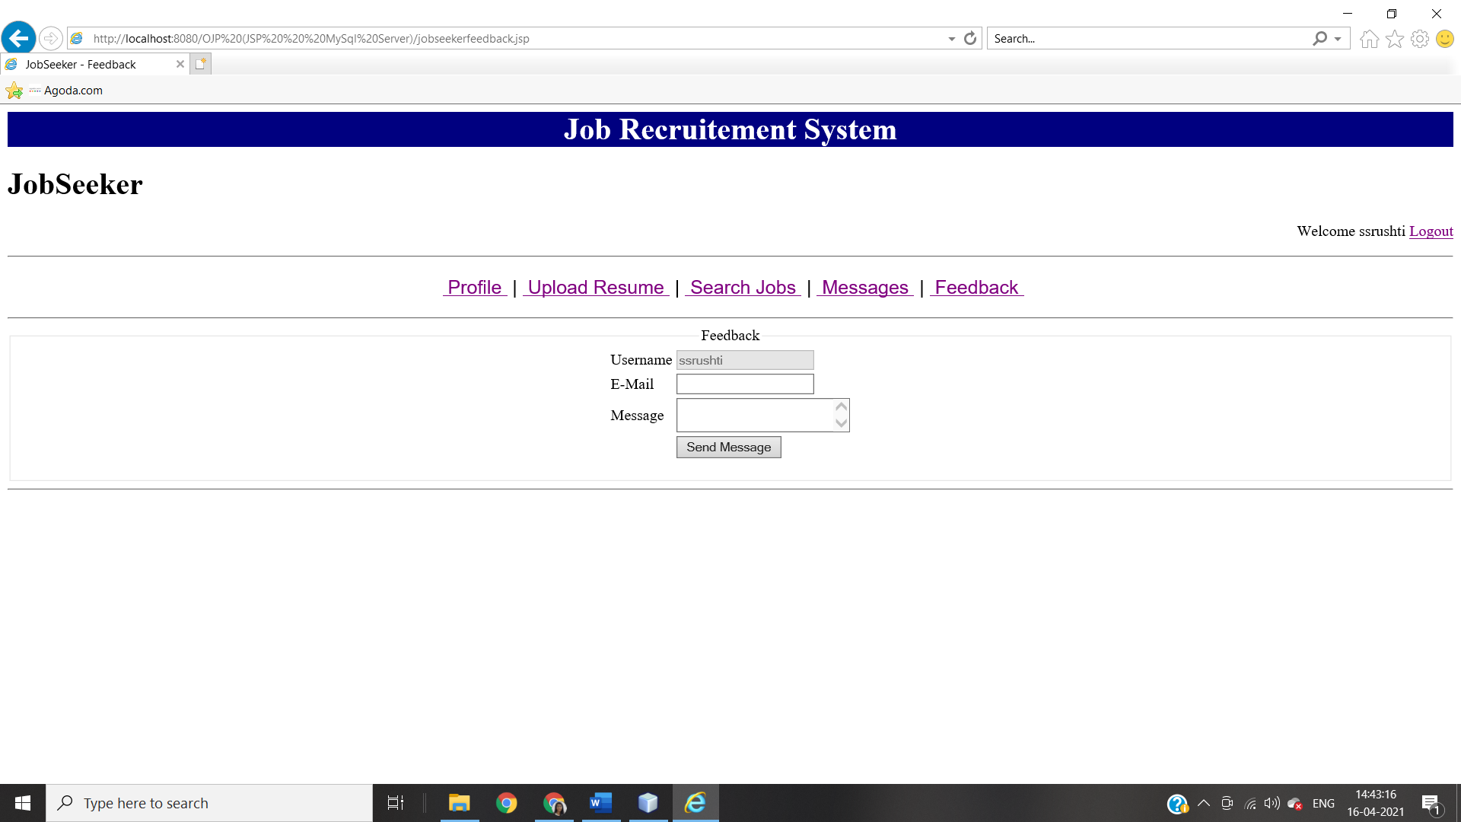

1. **RECRUITERS HOME PAGE MODULE INTEGRATION TEST**

RECRUITER HOME PAGE

JOBSEEKER SEARCH

COMPANY DETAILS

JOB POSTING

JOB POSTING

CONFIRMATION

REPORTS

JOBSEEKER PROFILE

SELECT FOR INTERVIEW

**RECRUITER HOME PAGE**

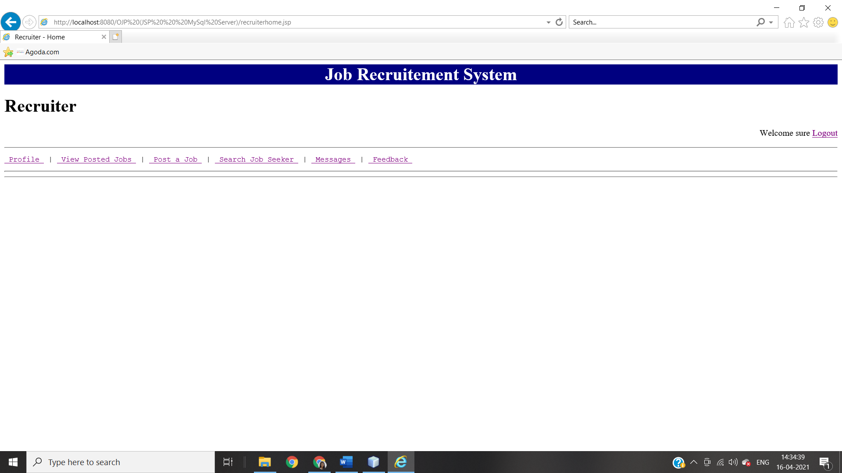

All possible activities for the recruiters are listed below.

1. Profile :-

This link is used to view/update profile of logged recruiter.

1. View Posted Jobs:-

This link will show jobs that is posted by current logged in user.

1. Post a Job:-

This link is used to post new job.

1. Search JobSeeker:-

This link is used to search registered jobseekers.

1. Message:-

This link is used to message box which contains information about jobseekers who have applied to jobs.

1. Feedback:-

This link is used to submit feedback about website.

**‘PROFILE’ PAGE ON RECRUITER**

**When Recruiter Updated There Details**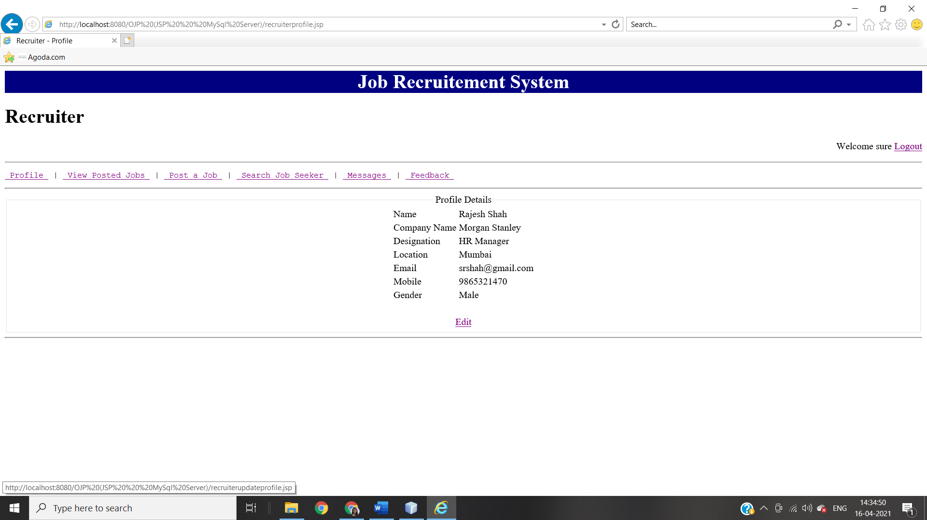

This page is for recruiter. All possible activities for the recruiter are listed here.

1. Edit: -

This link is used to edit/update logged recruiter’s profile details.

**When Recruiter Clicks On ‘Edit’**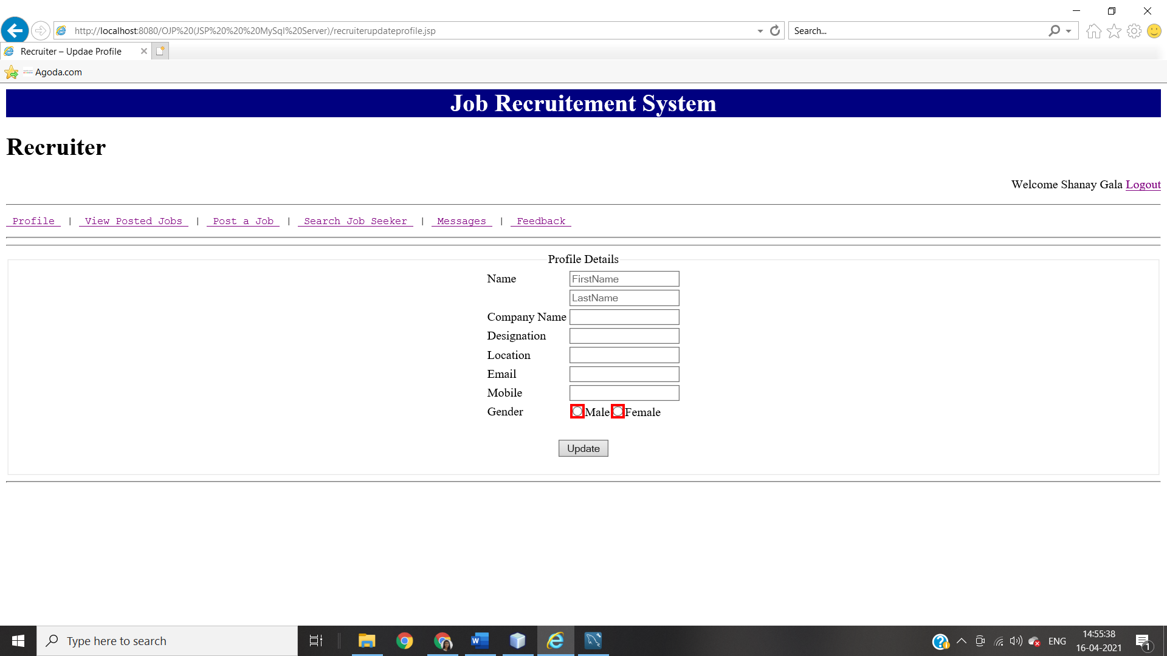By clicking on **‘Update’** Button Recruiter can update there profile details.

**When Recruiter Is New**

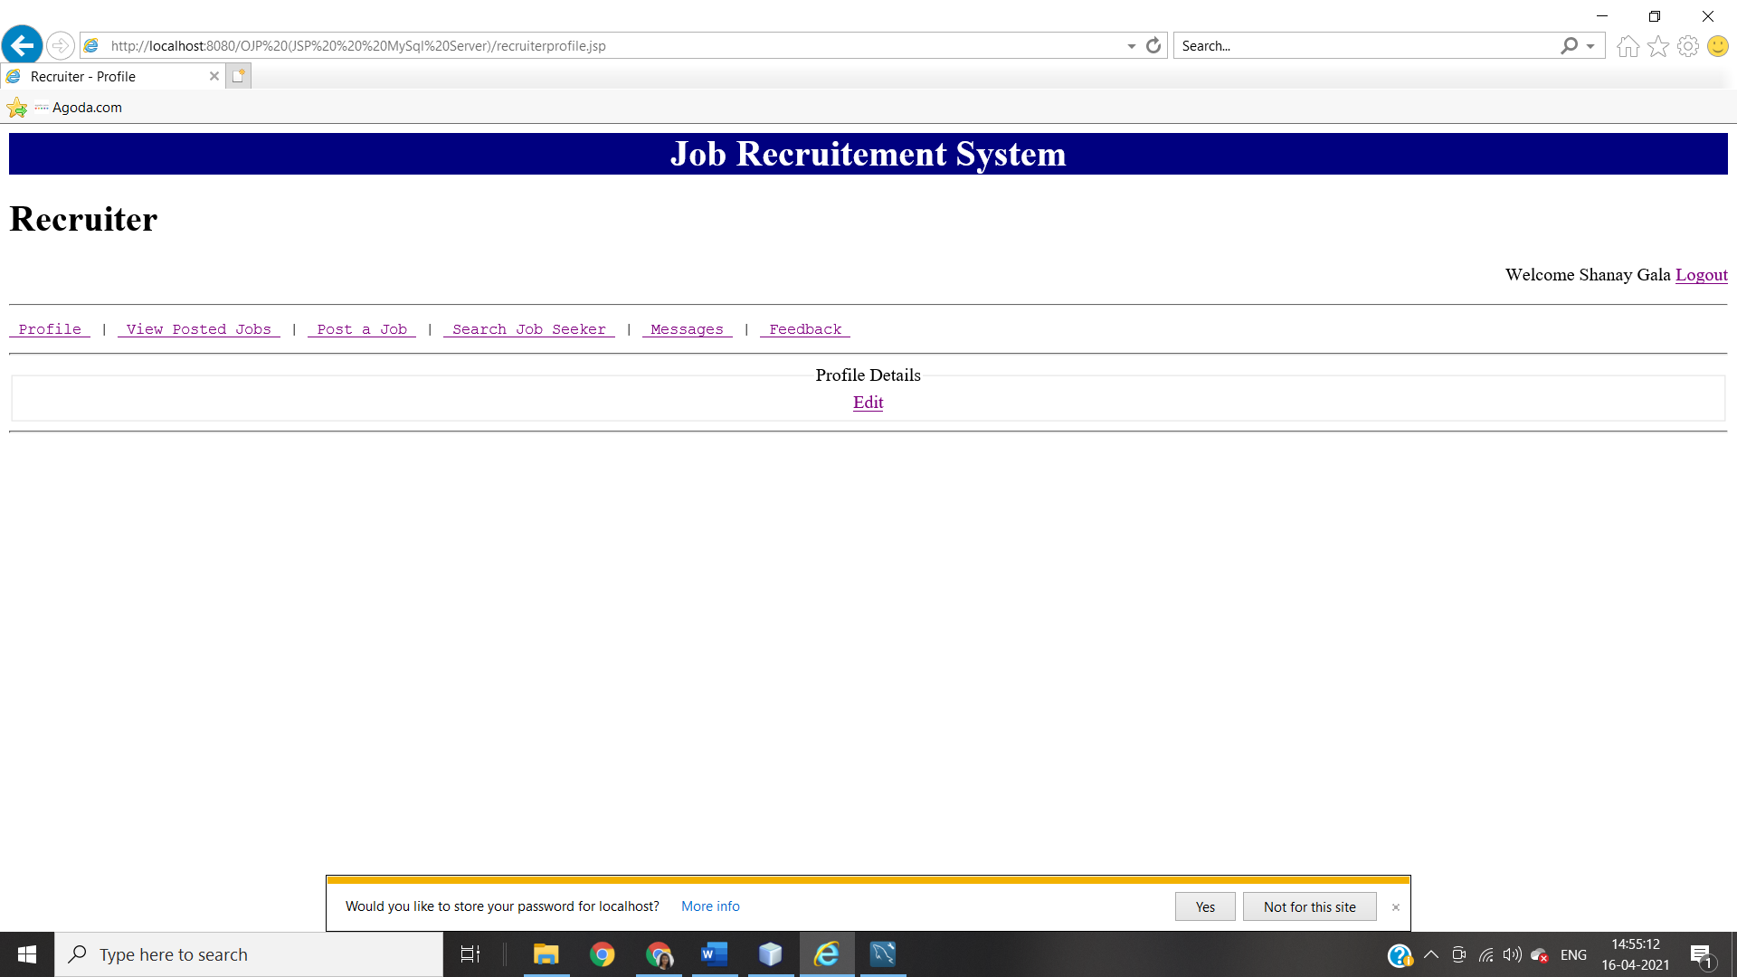By clicking on’**Edit**’ recruiter can edit there profile details

**‘VIEW POSTED JOBS’ PAGE ON RECRUITER**

**When There Is No Job Posted By Recruiter**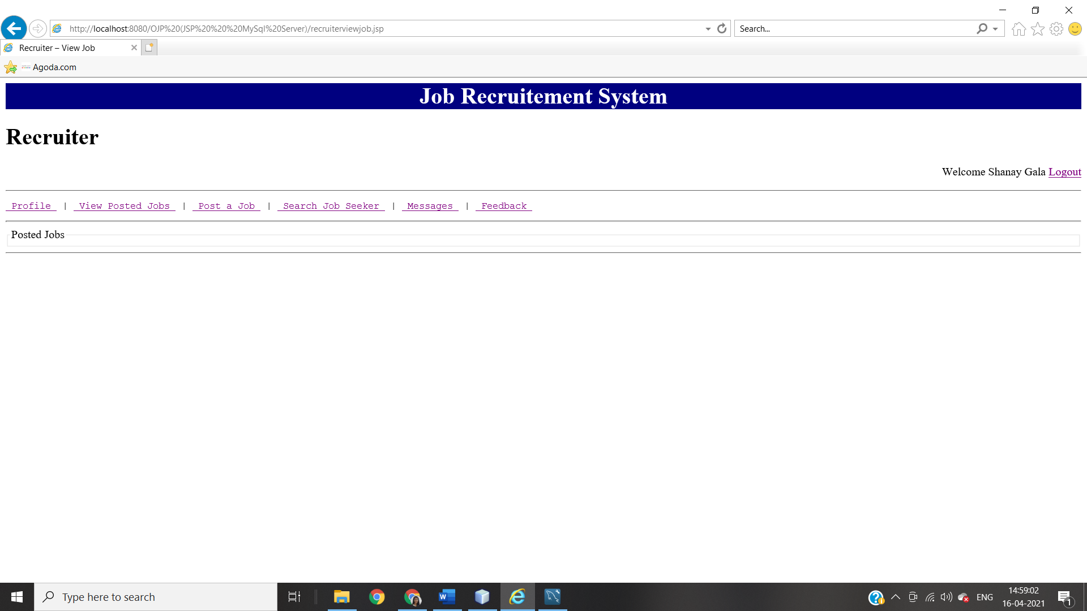

**When There Are Jobs Posted By Rectuiters**

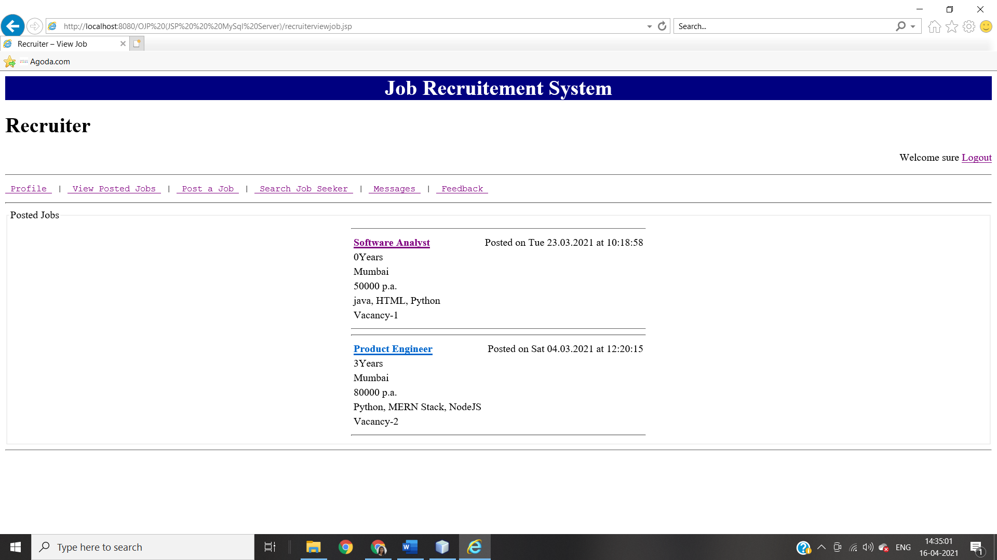 Recruiter can open JobSeeker’s Profile Page by clicking on that JobSeeker’s name.

**‘POST A JOB’ PAGE ON RECRUITER**

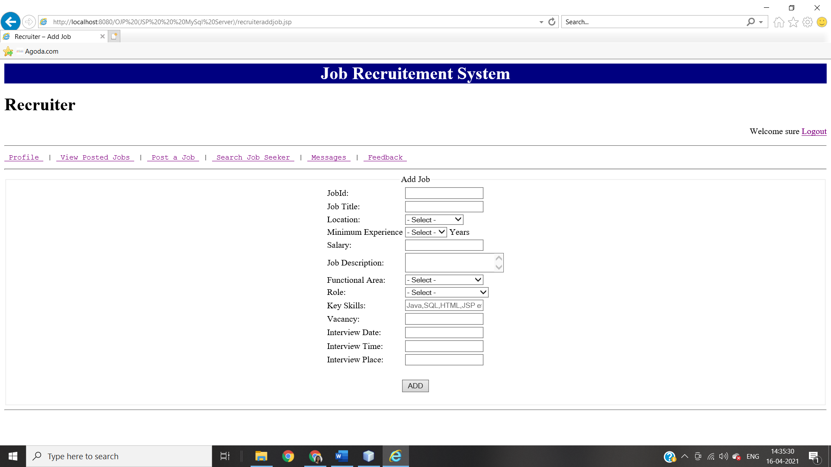

**JOB DETAILS PAGE ON RECRUITER**

**When Recruiter Views Jobs There Are No “Apply For Job” Option**

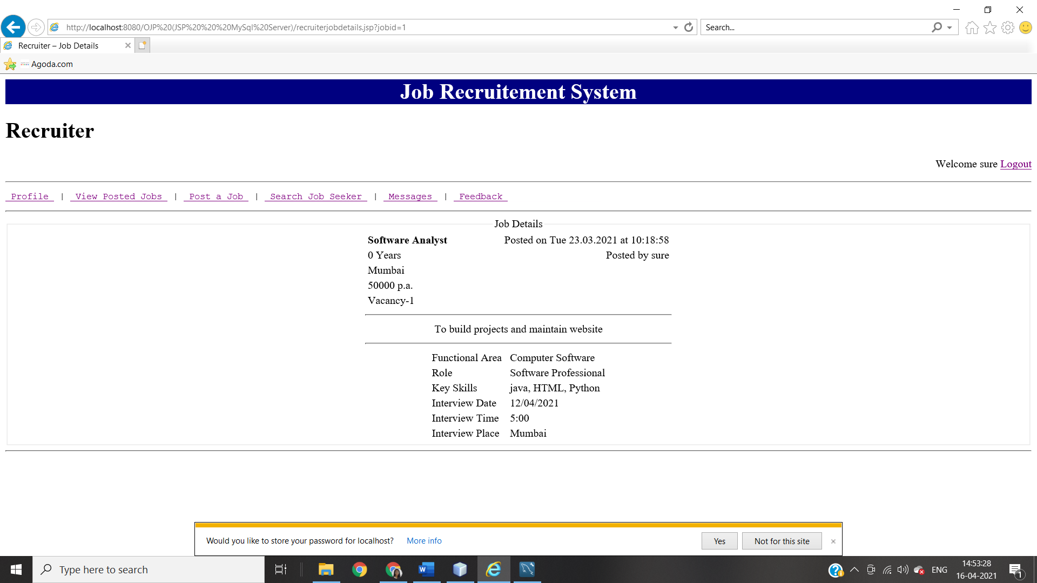

**‘SEARCH JOB SEEKER’ PAGE ON RECRUITER**

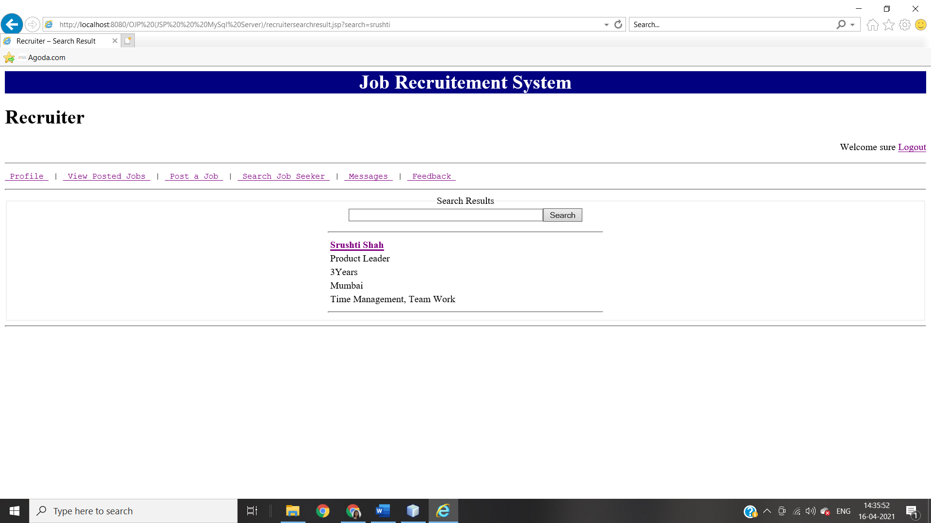

**JOBSEEKER PROFILE PAGE ON RECRUITER**

**When Recruiter Is Accessing JobSeeker Profile There Is ‘Send Message’ Option By Which Recruiter Can Send Message To That Perticular JobSeeker.**

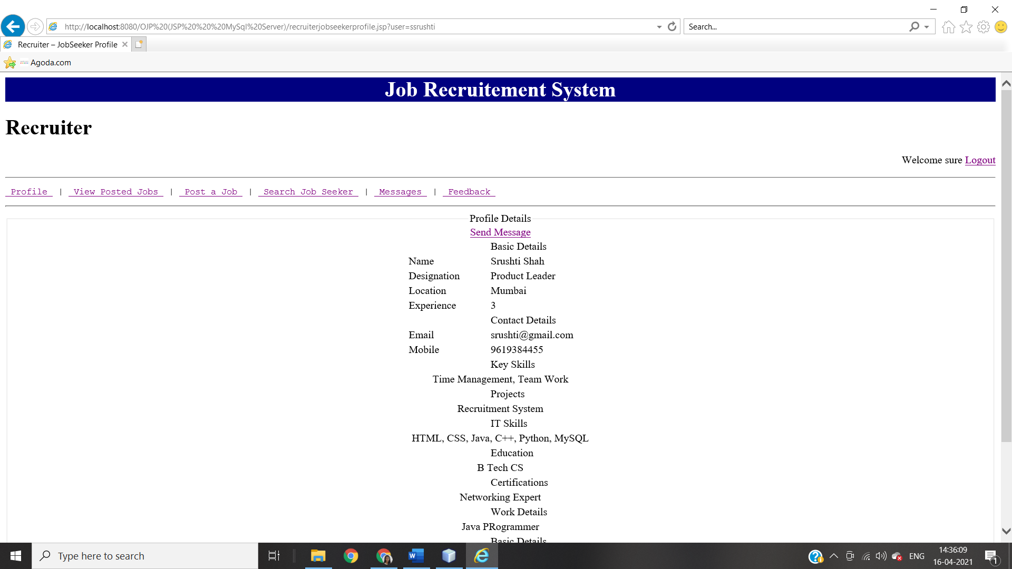

**‘Send Message’ Page**

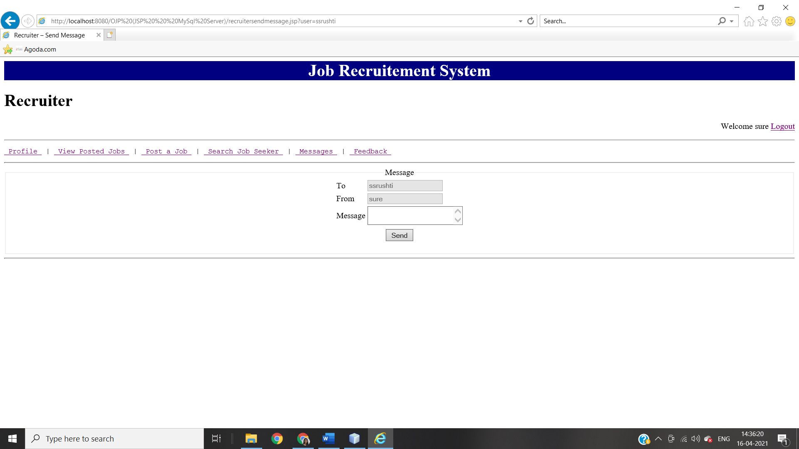

**‘MESSAGES’ PAGE ON RECRUITER**

**When There Is No Message For Recruiter**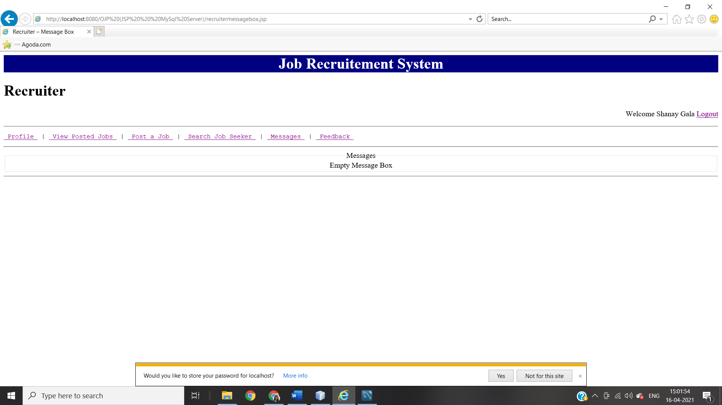

**When There Are Messages**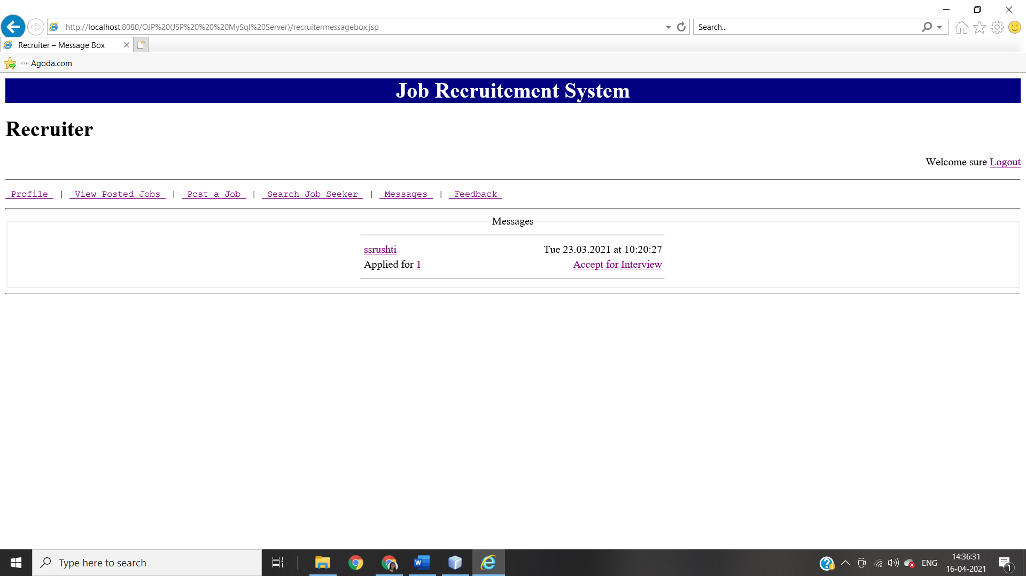

**‘FEEDBACK’ PAGE ON RECRUITER**

**Recruiter’s Feedback Page**

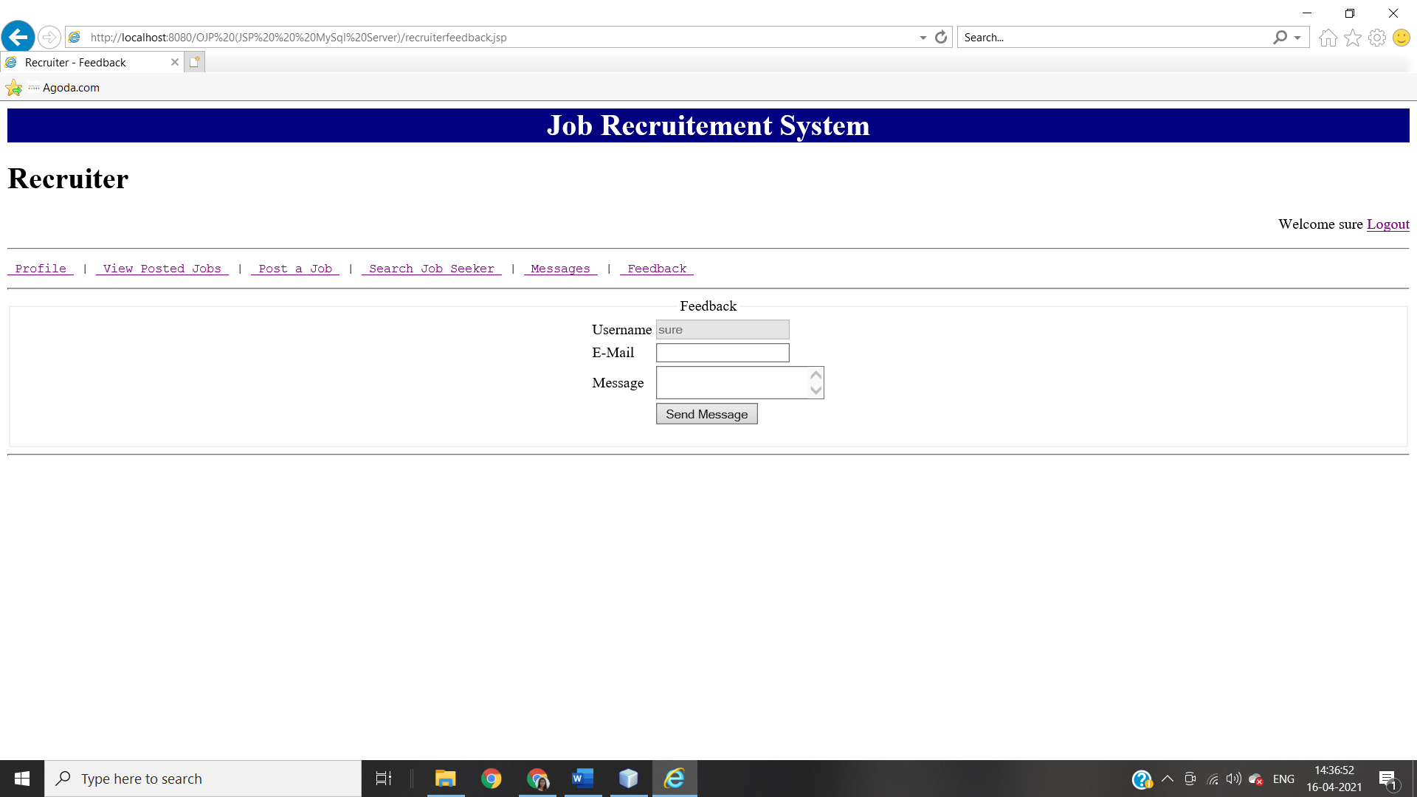

1. **ADMIN HOME PAGE MODULE INTEGRATION TEST**

ADMINISTRATION

DELETION

LOGIN

REPORT

DELETION

LISTING

CREATION

RECRUITER

JOBSEEKER

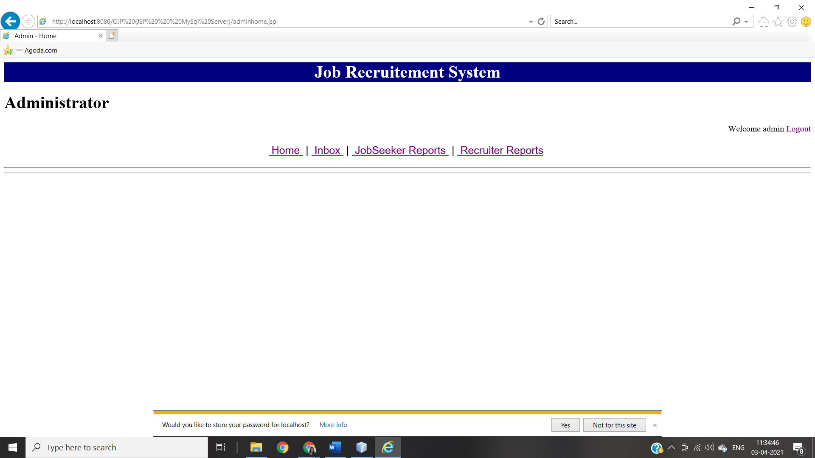

All possible activities for the administrator are listed here.

1. Home: - This link is for administrator homepage.
2. JobSeeker Reports.:- With the help of this link administrator can delete or view JobSeekers profile.
3. Recruiter Reports: From this link administrator can manage recruiters profile.

**‘JOBSEEKER REPORTS’ PAGE ON ADMINISTRATOR**

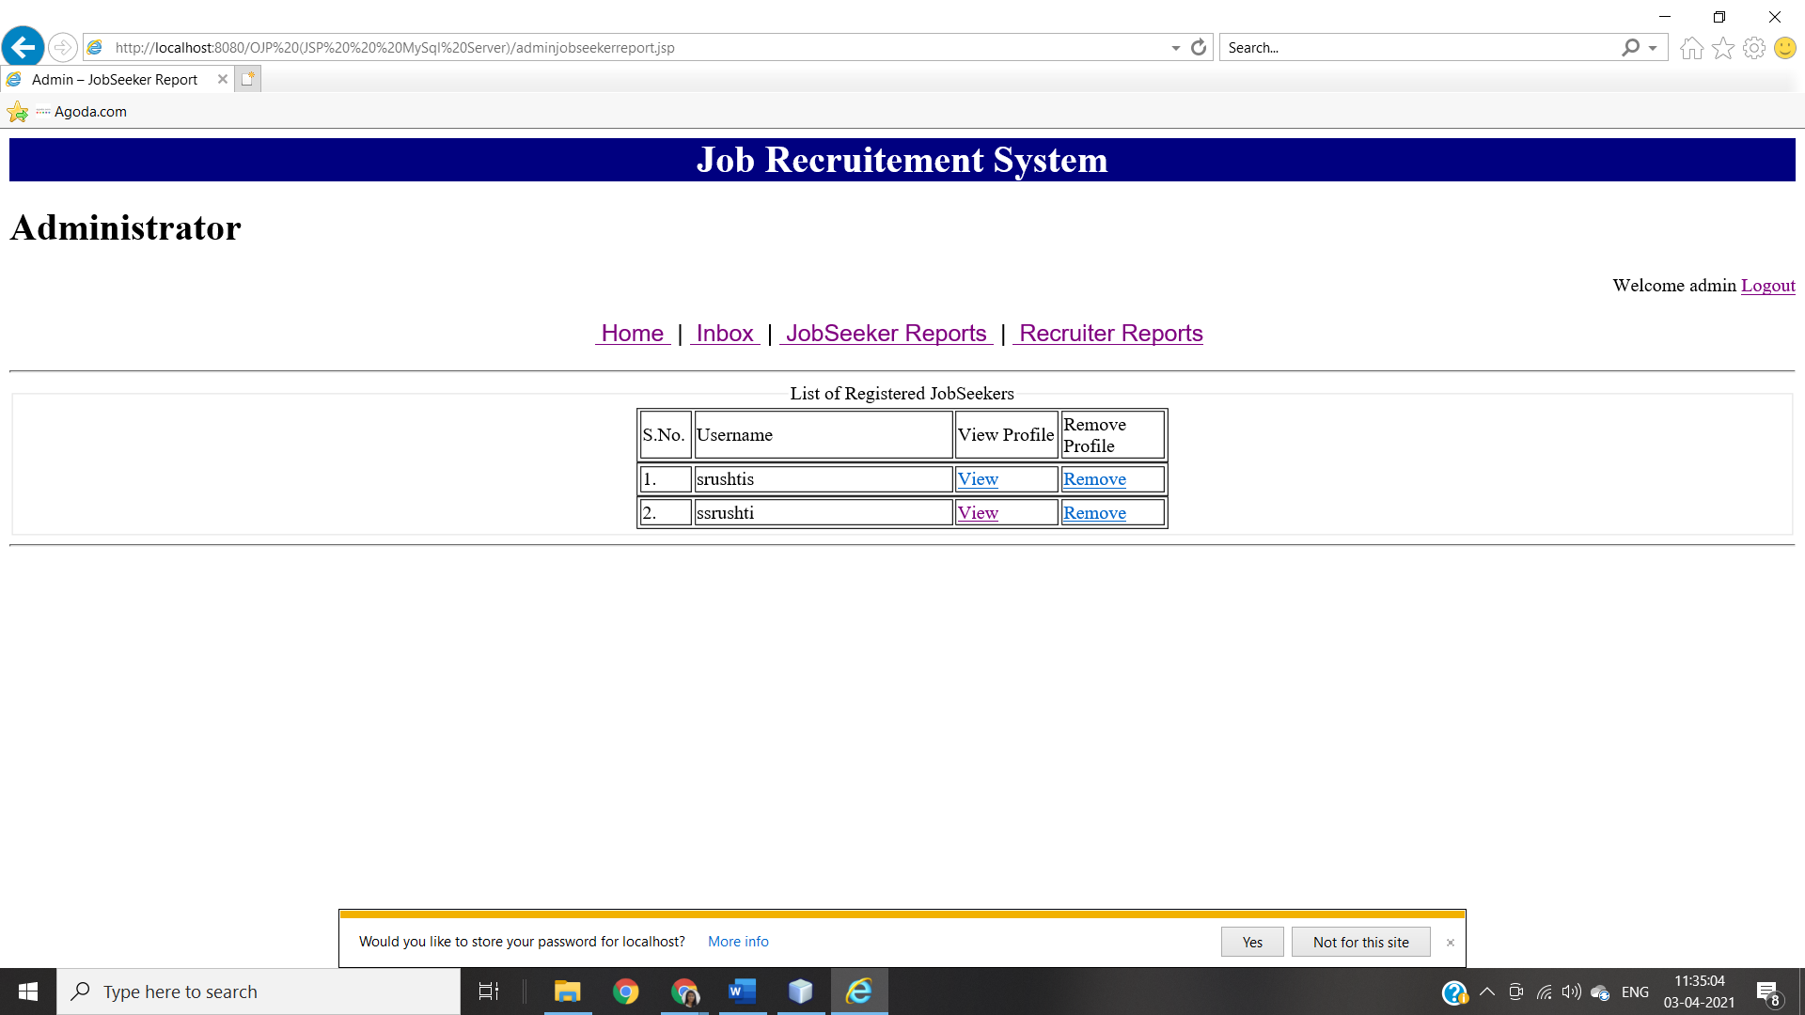

This page is for administrator. All possible activities for the administrator are listed here.

1. View: - This link will open correspondence jobseeker’s profile page.
2. Remove: - This link will remove correspondence jobseeker’s profile from database.

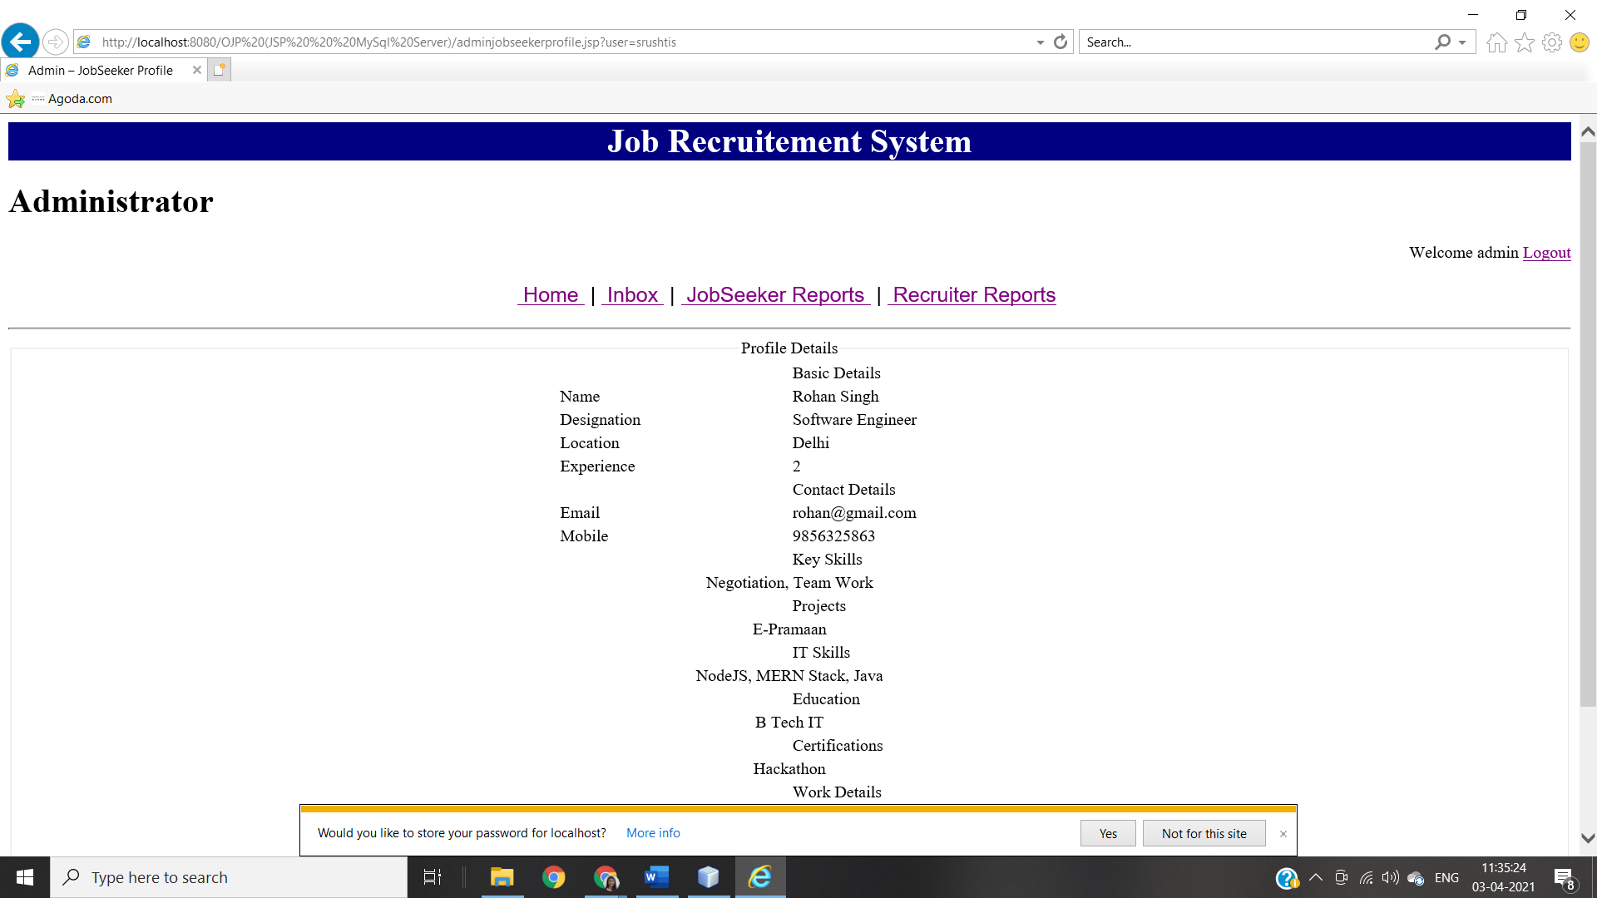

**‘RECRUITER REPORTS’ PAGE ON ADMINISTRATOR**

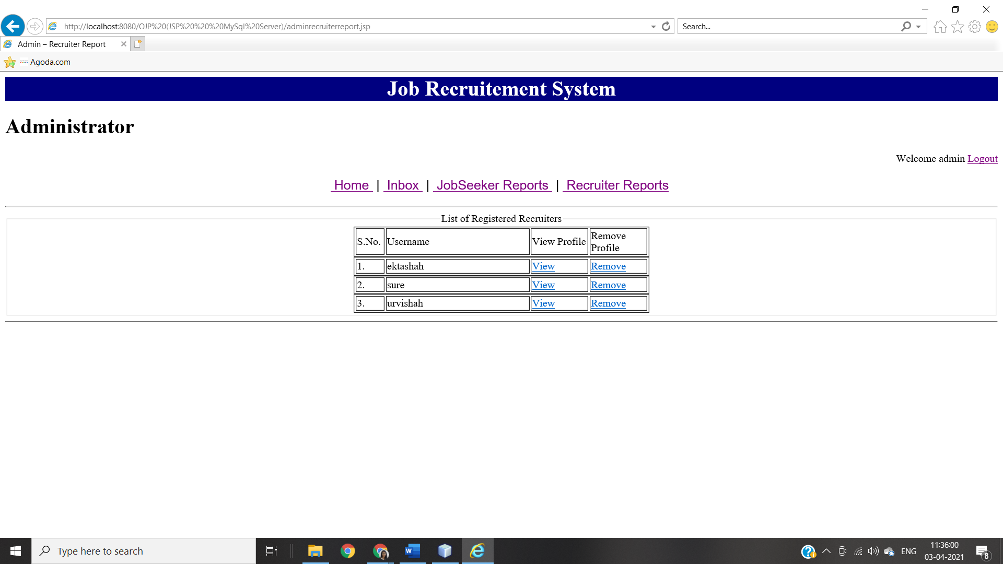

This page is for administrator. All possible activities for this page are listed here.

1. View: - This link will open correspondence recruiter’s profile page
2. Remove: - This link will remove correspondence recruiter’s profile from database.

***CONCLUSION:***